06/12/2019

**Task:**

* Create a live plot in python
* Remove the impulse created by the DC offset of signal at 0 Hz.

**Issue:**

Performing FFT, the signal captured by the accelerometer I noticed that a large impulse was displayed around frequency 0Hz, thus masking out the signals of interests with relatively small amplitude

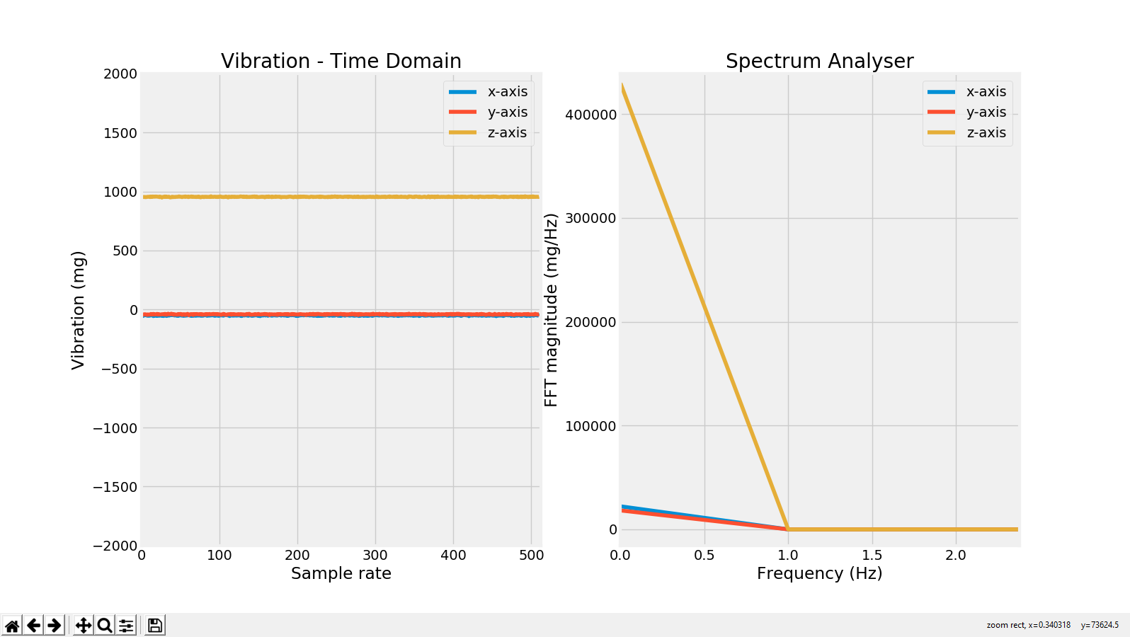

This was the result of the DC offset, the average of all the samples in the window.

**Solution:** After investigation two methods can be applied to remove DC offset from the original signal before performing FFT:

* Applying High-Pass Filter
* Subtractiong the Mean of the Original Signal

I opted to subtract the mean of the signal and made use of the detrend() method available in Scipy library to eliminate this:

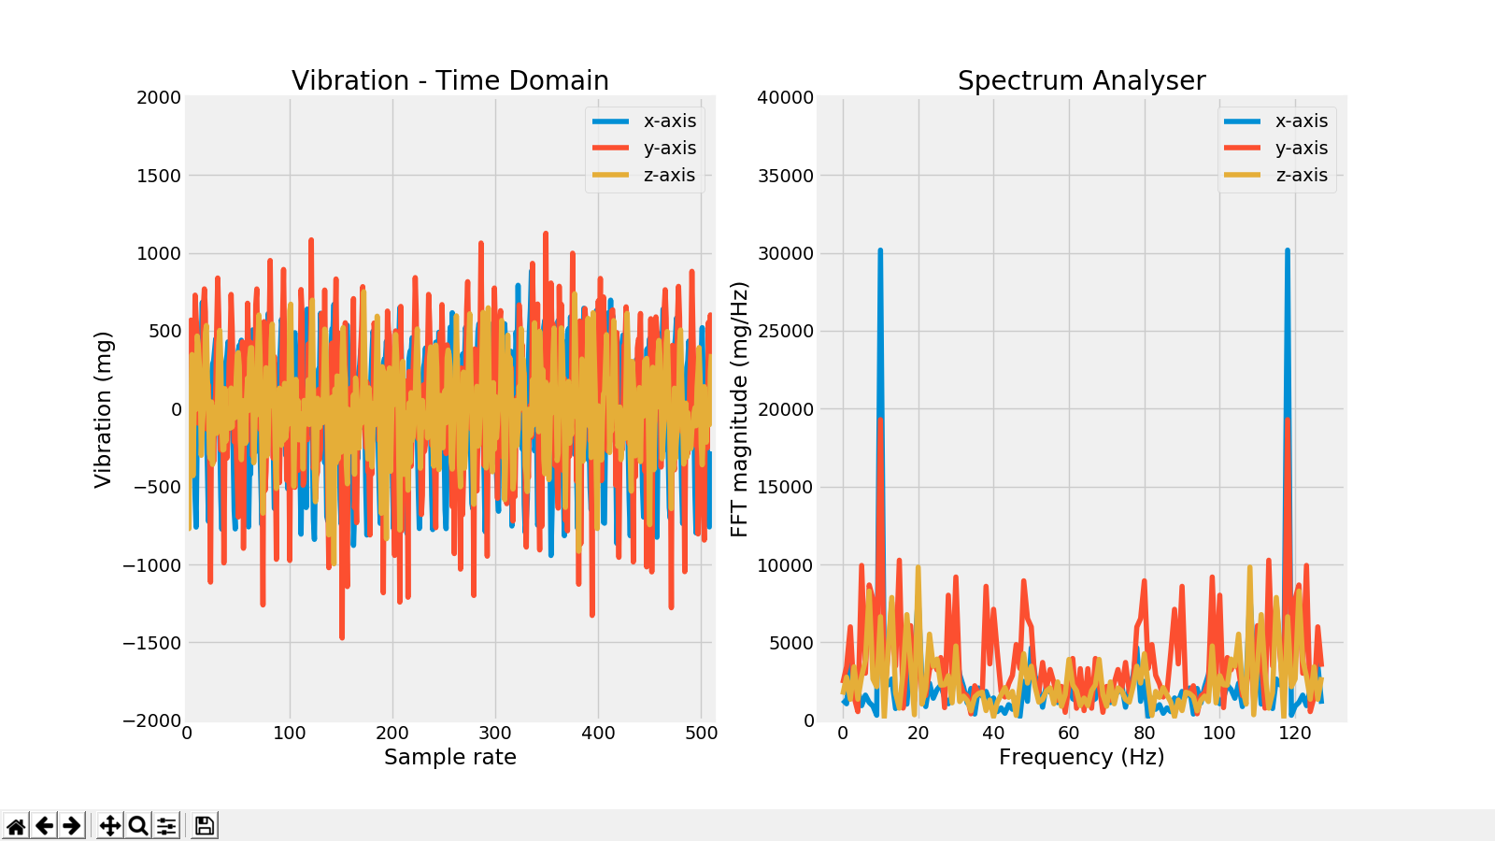

As shown above I could remove the DC offset.

**References**

<http://blog.originlab.com/data-handling/how-to-remove-dc-offset-before-performing-fft>

<https://www.mathworks.com/help/dsp/ref/dsp.spectrumanalyzer-system-object.html>

<https://makersportal.com/blog/2018/8/14/real-time-graphing-in-python>

<https://www.analog.com/en/analog-dialogue/articles/intro-to-mems-vibration-monitoring.html>

<https://www.researchgate.net/post/What_is_the_effect_of_DC_on_fft_in_MATLAB>

<https://docs.scipy.org/doc/scipy/reference/generated/scipy.fftpack.fft.html>

<https://stackoverflow.com/questions/25735153/plotting-a-fast-fourier-transform-in-python>

<https://stackoverflow.com/questions/51429792/unexpected-fft-results-with-python>

<https://matplotlib.org/3.1.0/gallery/style_sheets/style_sheets_reference.html>

<http://greenteapress.com/thinkdsp/thinkdsp.pdf>

<https://open.umn.edu/opentextbooks/textbooks/think-dsp-digital-signal-processing-in-python>

<https://matplotlib.org/3.1.1/api/_as_gen/matplotlib.pyplot.subplots.html>

<https://www.python-course.eu/matplotlib_subplots.php>

<https://matplotlib.org/3.1.1/tutorials/introductory/pyplot.html#sphx-glr-tutorials-introductory-pyplot-py>

<https://en.wikipedia.org/wiki/Nyquist%E2%80%93Shannon_sampling_theorem>